**Consequences of the Covid-19 pandemic on the world economy**

**World map of GDP changes and corona related deaths in R**

Mie Arnau Martinez (MAM) (Student ID: 201806701)

School of Communication and Cognition, University of Aarhus,

Jens Chr. Skous Vej 2, 8000 Aarhus, Denmark

**Abstract**

In the light of the Covid-19 crisis, countries and states have instituted lockdowns and reduced production worldwide. However, not all countries approached the problem in the same way and therefore countries were not similarly affected. Some countries closed all retail and sent people home from work while others kept to a business-as-usual approach. This paper aims to investigate the consequences of the pandemic on the individual countries. Which countries came out unscathed and which where most affected by the fast spread of the virus? For this, I examined the number of Covid-19 related deaths as well as how the pandemic affected the countries GDPs.

**Keywords:** *Covid-19, lockdown, pandemic, GDP*

Introduction: Approaches for damage-control

**Introduction, problem and background**

Coronavirus disease 2019 (Covid-19) is an infectious disease that is believed to have originated in a food market in Wuhan, China (Wu et al, 2020). Since then, the virus has been detected in numerous countries across the continents (REF). One might argue that this is the result of having a globalized world in which people are travelling more than ever before as it allows for contagious diseases to transmit across borders (REF). However, this also means that pandemics could be a recurring problem. Therefore, it is important to examine the different approaches of stopping the spread of the virus. It is important to know what worked and what didn’t work so that we can be more prepared for the next virus. So, what is the most effective damage-control during a pandemic? To investigate this, I will look at all countries to see how they were affected by the virus. Specifically, I will examine the change in gross domestic product (GDP) in 2019 and 2020 to see how the Covid-19 influenced the economy. Moreover, I will look at the number of people that died from Covid-19. These parameters are chosen due to a believed negative correlation between number of people who died from the virus and how well the economy

What is Covid-19 and why should we care?

What is the motivation of developing a program to look at the consequences of Covid-19?

Does it have cultural relevance?

It is important to examine consequences of different approaches of damage control. The main reason for this is to know how to best approach the problem next time.

**Software framework**

To undertake my project, I used a 6-months old Lenovo IdeaPad S340-14IIL, 8 Gb RAM, which runs the Windows 10 operating system. Furthermore, the data preparation, analysis and data visualizations were produced in RStudio (1.3.959) with the desktop version of R (4.0.0). Moreover, various libraries were loaded from the Comprehensive R Archive Network (CRAN) package repository. These include the **rgeos**, **ggplot2**, **SF**, **rnaturalearth** and **ggspatial** packages which were used for displaying the data on a world map. Additionally, world data was acquired through the package **rnaturalearthdata**. The project consists of two scripts. The first script is for data acquisition and preprocessing. The second script is for data visualization and correlation analysis.

**Data Acquisition and Processing**

For the project, web scraping was used to obtain data on number of people who died of Covid-19 in each country. The data was retrieved from statista.com (See *Table 2, D1*). After retrieval, the data was in the format of a single string. Therefore, preprocessing was needed to transform it into a data frame. Mainly, this consisted of substitution with regular expressions.

The data for changes in gross domestic product in 2019 and 2020 was downloaded as an Excel file from the International Monetary Fund (imf.org – See *Table 2, D2*). Minimal preprocessing was needed for this data set.

For more details on data acquisition and preprocessing see [LINK TO GITHUB].

Lastly, data of all countries and their vector maps etc. was acquired through the CRAN packages **rnaturalearth** and **rnaturalearthdata** (South, 2017).

**Implementation and empirical results**

To make a simple presentation that shows how Covid-19 have had a different impact on each country, I decided to make world maps. This is an approach to express information of many variables and incorporating them in a way that is fast and easy to interpret.

The first map (*Figure 1*) shows Covid-19 casualties by country in 2020. From this, it is apparent that the United States of America had the highest number of deaths of approx. 300.000. However, this does not account for population differences. Therefore, a second map was created (*Figure 2*). Here, the number of casualties are divided by population. Furthermore, the numbers are transform logarithmically. This transformation had the purpose of drawing outliers closer to the mean. Thereby, differences between the countries are more prominent than they would have been without the transformation. In fact, without the log-transformation the map appeared to show no differences across countries.

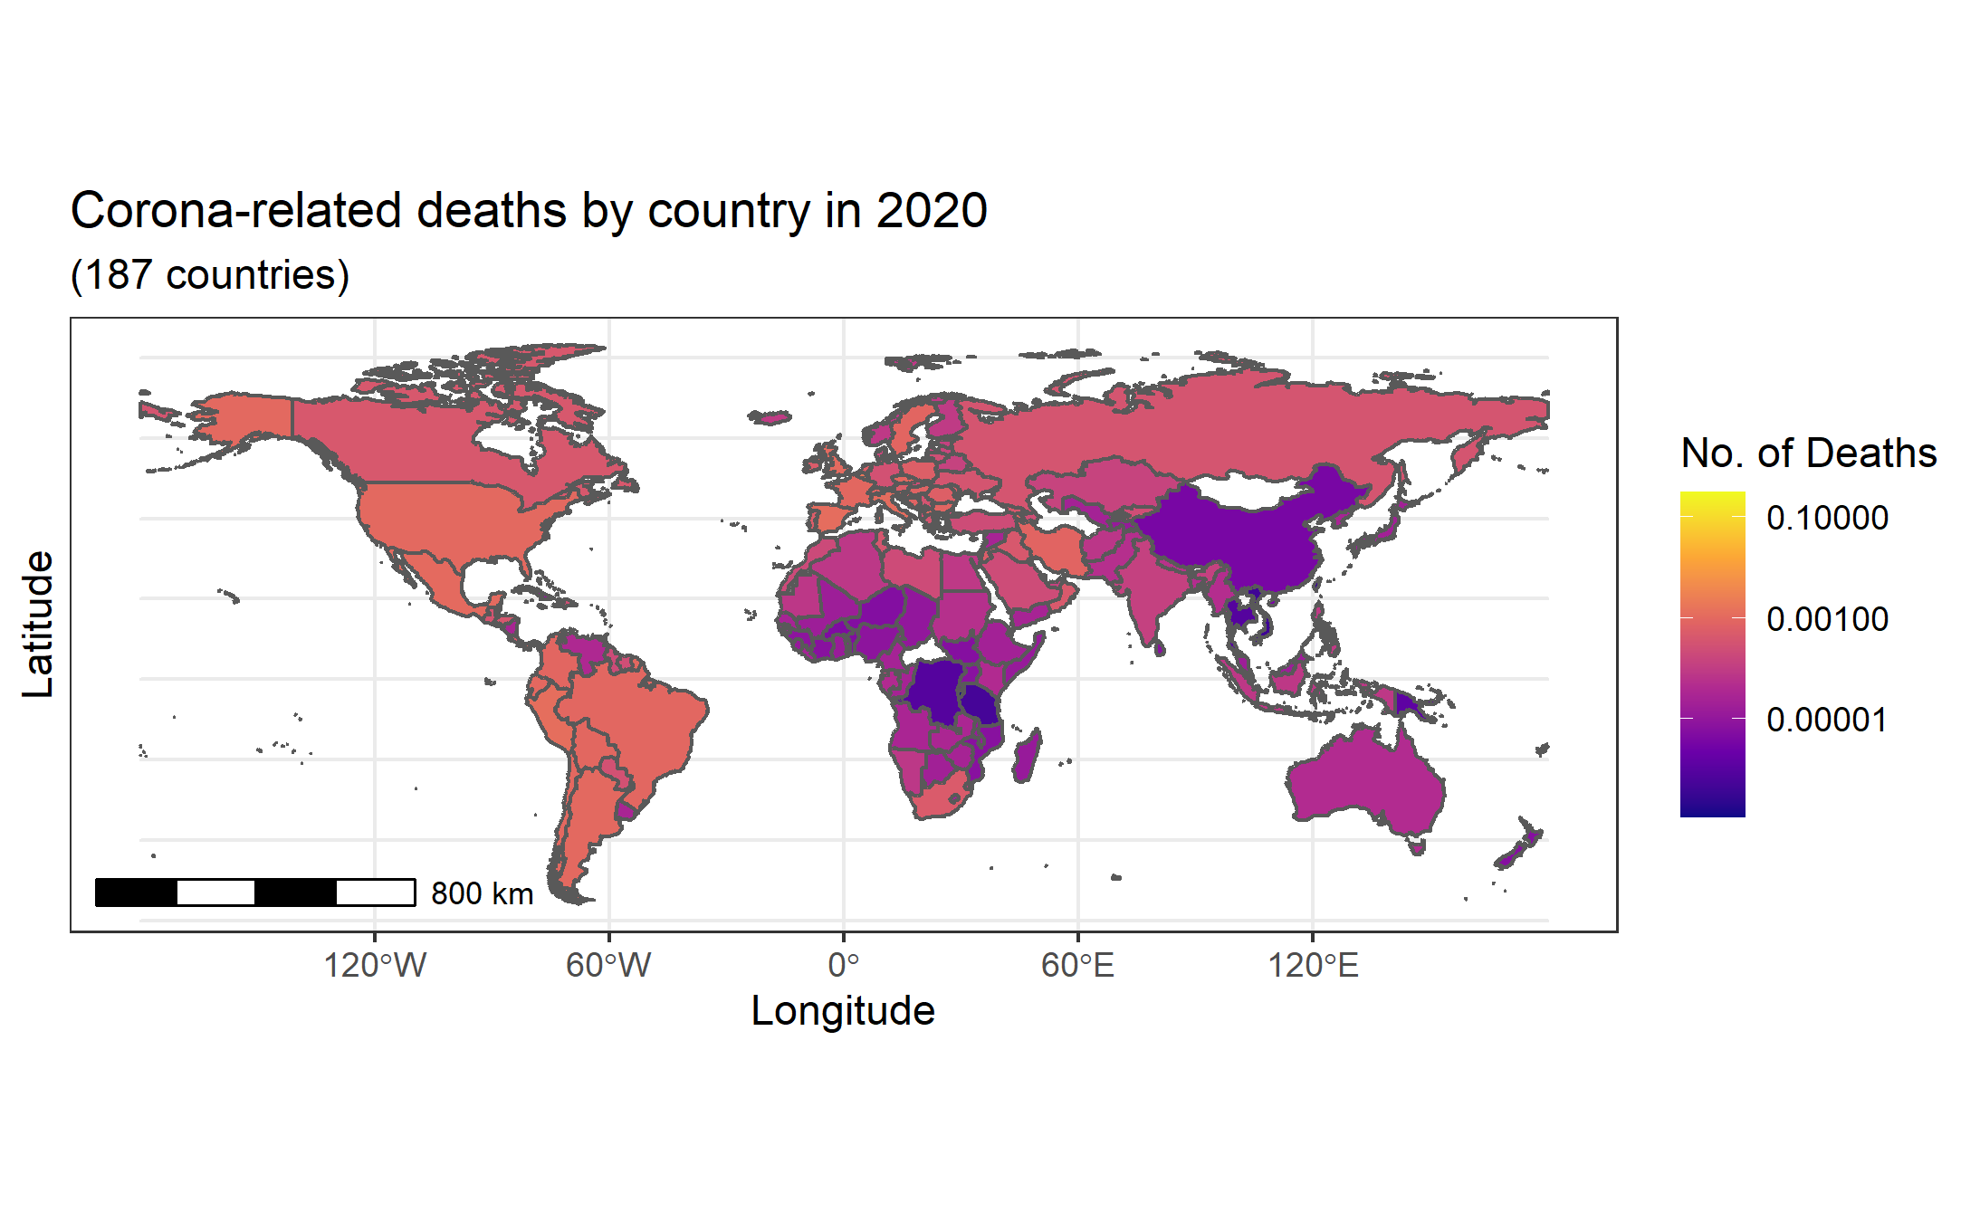

Figure 1 - World map of the Covid-19 casualties per capita. The data has been log-transformed to enhance the across-country differences.

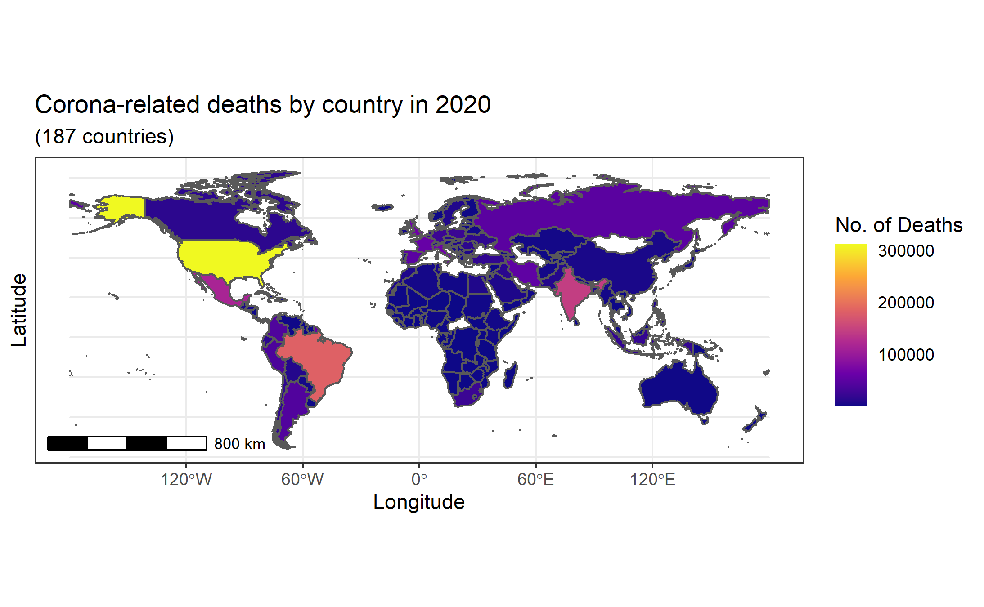

Figure 2 - World map displaying the raw numbers of Covid-19 casualties in 2020.

These maps (*Figure 1 and 2*) show a great overview of how fatal the disease was for the world. However, it can be hard to see exactly how each country was affected. Therefore, I used the “coord_sf()” function to zoom in on Europe (*Figure 3*). Moreover, I added labels for each country to facilitate identification. The greatest problem encountered was the placement of the countries’ names. First, I tried using the function “st_centroid” recommended by the r-spatial guide (Moreno and Basille, 2018). However, this resulted in incorrect placing of country-labels. For instance, the “France” label was placed in the polygon that represents Spain. For this reason, I looked into the sf package and found another operation that improved the location of the labels, i.e. “st_point_on_surface()”. So, instead of calculating the centroid as the point in which to put the label, the latter function simply places the label within the surface of the

polygon. The result can be seen in *Figure 3*. Here we can see that the countries with least number of deaths included Norway, Finland, Iceland and Belarus. Likewise, the countries with highest number of Covid-19-related deaths includes Spain, France, Italy, Belgium, the UK and Sweden.

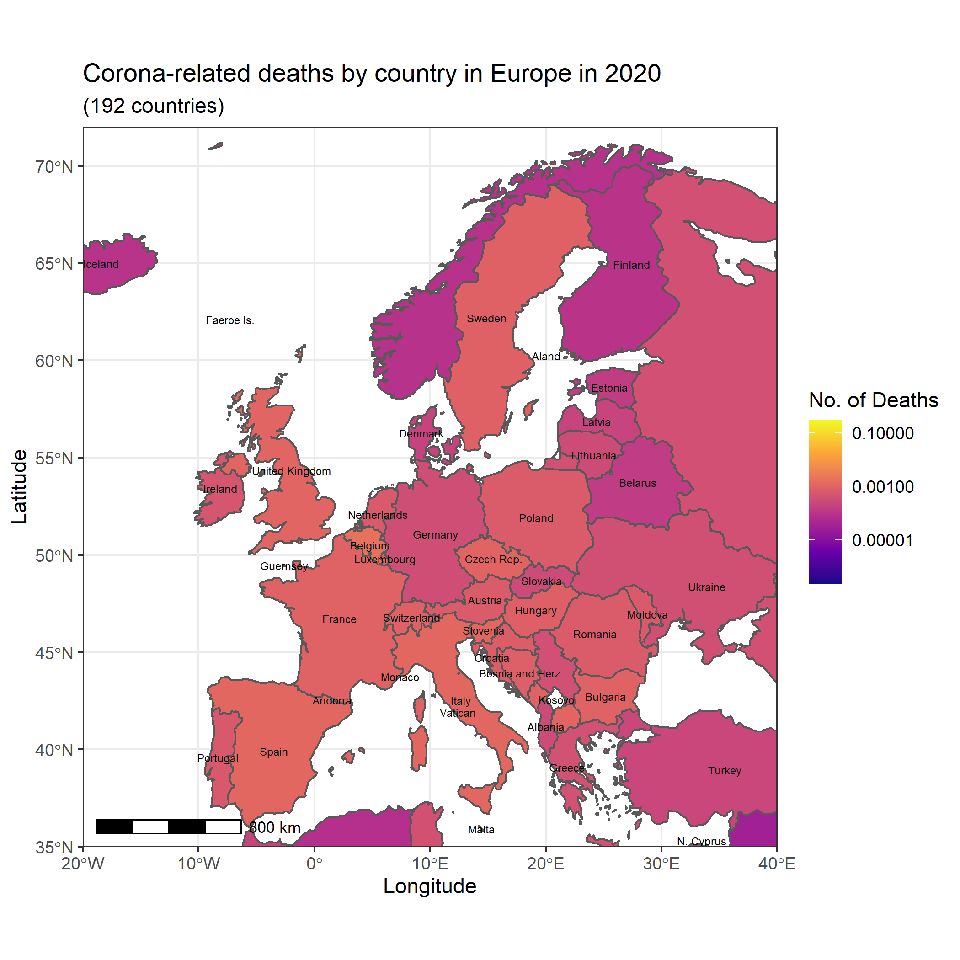

Figure 3 - Map of Europe showing Covid-19 casualties per capita

The second parameter that I examined was the change in gross domestic product (GDP) in both 2019 (*Figure 4*) and 2020 (*Figure 5*). The reason to include both years is that they are linked. For instance, if a country has a great negative change of GDP in 2019 the change of GDP might not be as affected by Covid-19. Similarly, if a country was flourishing in 2019 the Covid-19 crises might have hit more severely. As an example of the latter, Libya had a very positive development in their GDP in 2019 (see *Figure 4*). However, they had a very negative change in GDP in 2020 (see *Figure 5*). Notably, they were also one of the African countries with highest number of deaths per capita (see *Figure 2*).

It should be noted that the scales of the gdp color scheme changed between the two maps of GDP changes by country in 2019 and 2020 as the difference between countries’ gdp changes got smaller in 2020. Yet, overall the maps show that most countries had a positive development in 2019 and a negative development in 2020.

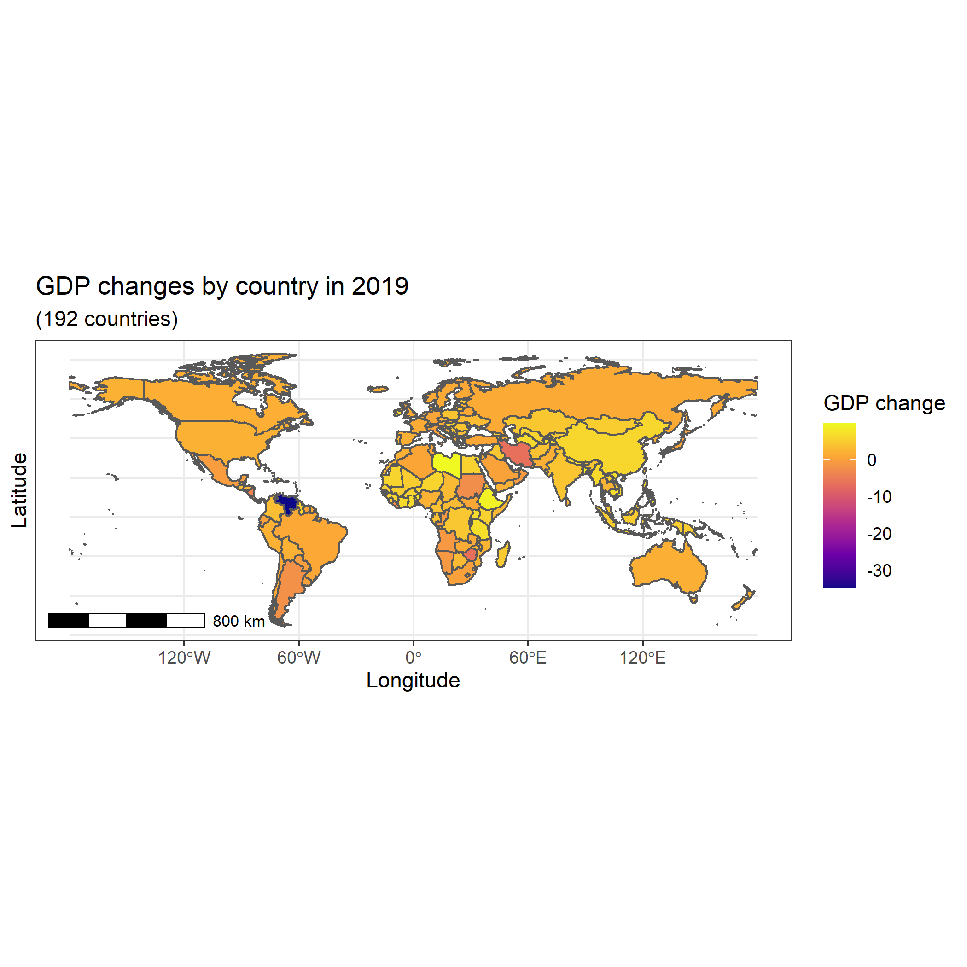

Figure 4 - Gross domestic product (GDP) changes by country in 2019

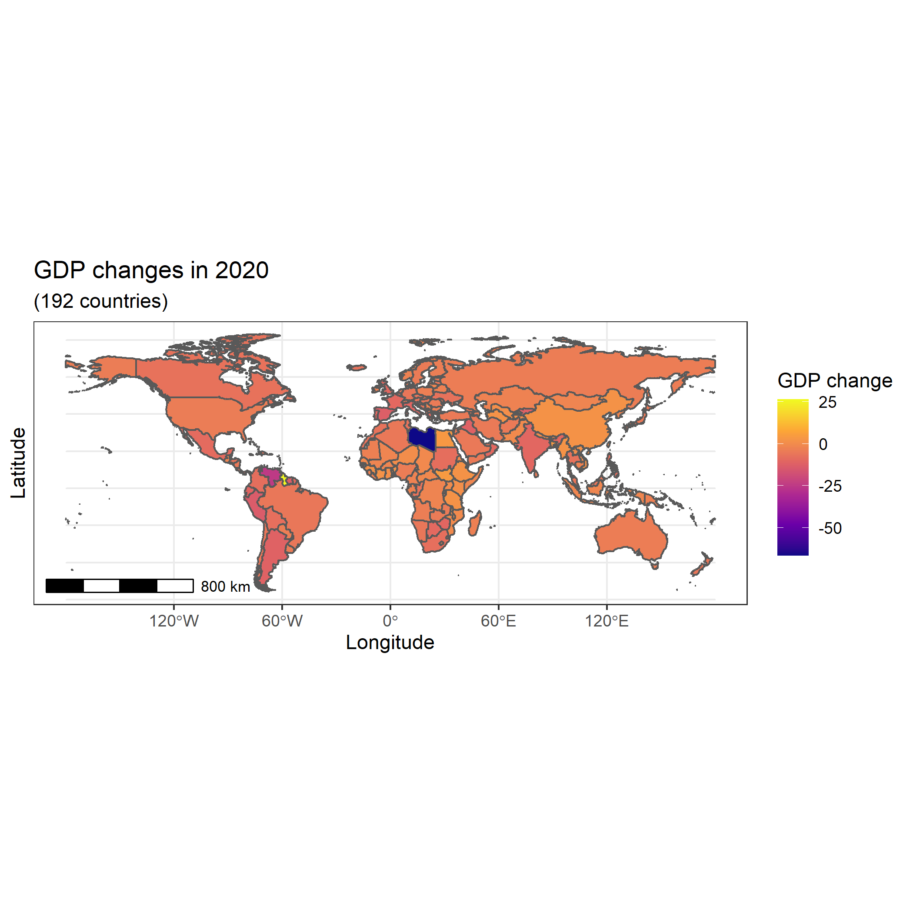

Figure 5 - Gross domestic product (GDP) changes by country in 2020

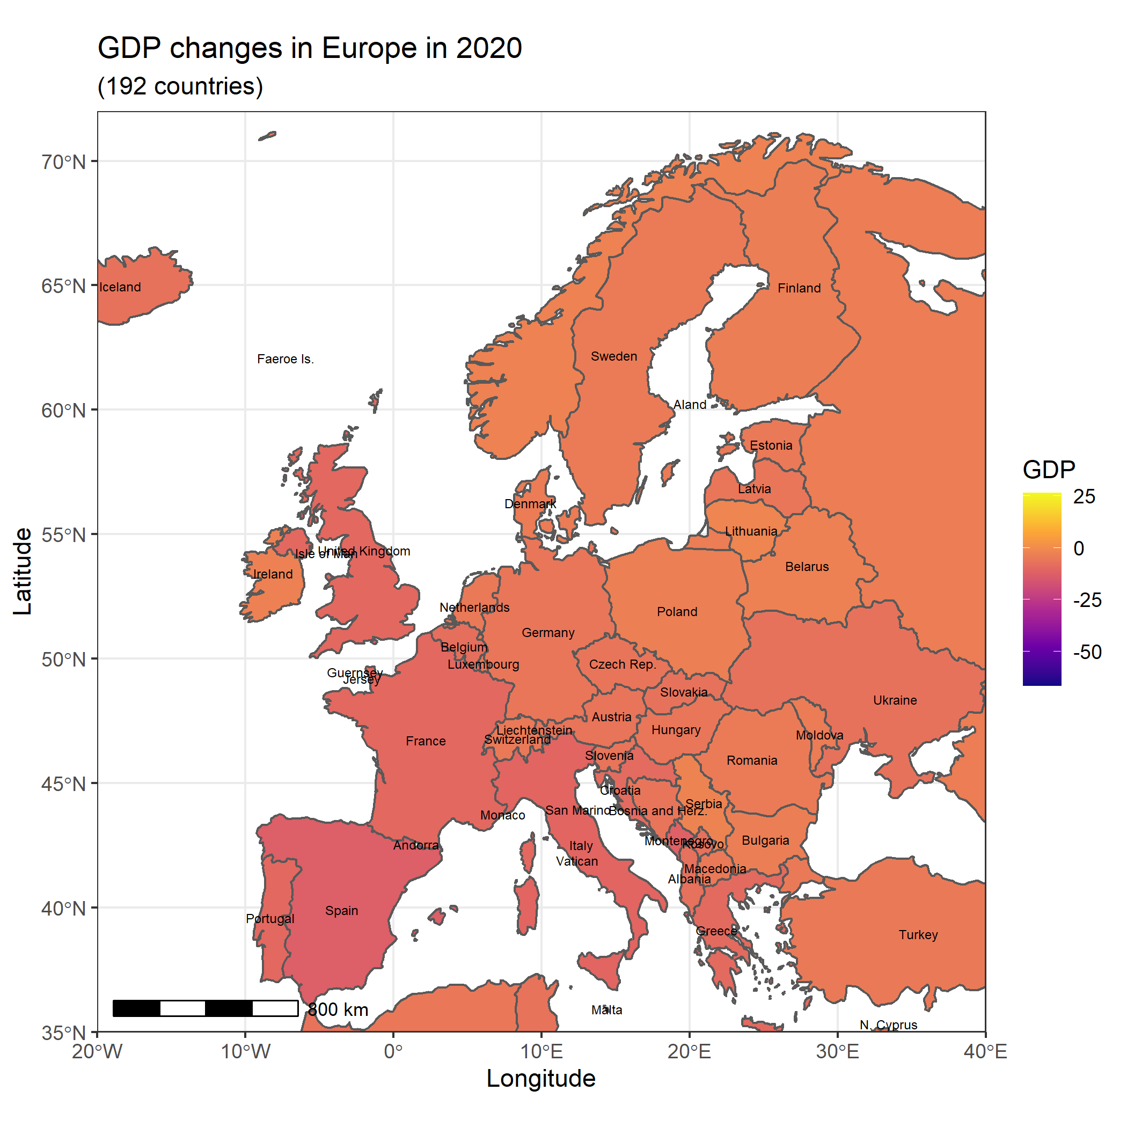

**Critical Evaluation**

**Conclusion and Acknowledgement**

**A - Free text**

*Description of your final project plus script or software in 2000-3000 words – suggested format follows;*

***1 Introduction / Goal***

* *Introduce the motivation for developing your research project, and explain why it is important and what its cultural relevance is (please use language accessible to non-specialized but intelligent audience)*

***2 Problems and Background***

* *Give the formulations of (cultural, historical, social, technical, etc.) problems to be solved by the project and role of the different digital tools in achieving the aims of the project*
* *Introduce the background and related work in literature (cite or list relevant literature, algorithms used, other scripts and software etc.)*

***3 Software Framework***

* *Give a short overview of the overall software architecture, dependencies and prerequisites if relevant, including the operating system of your machine, main software packages and their versions, and any cloud-based solutions necessary for a successful reproduction of the project results.*

***4 Data Acquisition and Processing***

* *List and cite all sources of data used in this paper*
* *Details of data extraction, filtering and preparation. Attach or link to processing scripts where relevant.*

***5 Implementation and Empirical Results***

* *Here you can provide either 1) a write up which presents in broad strokes the main elements of your digital workflow, pointing to specifics in the script, and highlighting decision-making bottlenecks and/or functions/tricks you found useful and wish to promote or credit. Alternatively, you can provide 2) the full annotated script, such as rmarkdown, demonstrating and documenting all major functions and decisions behind them.*
* *Empirical Results (product of your script ~slides, map, outline, timeline…)*

***6 Critical evaluation***

* *Critical assessment of the data sources (representativeness, reliability, etc.)*
* *Evaluation of the digital tools, the learning process, time on task, vis-à-vis the final product.*
* *For 'technical pipeline' projects: Provide a comparison with other state-of-the-art software if any exists for the same task* ***(****kindly cite relevant work, scripts, etc.****)***

***7 Conclusions***

* *Set out the conclusion of the project, summarize the achieved goals and highlight the most important lessons learnt while working on the project.*

***\*Acknowledgements***

* *Optionally thank people and institutes you need to acknowledge*

***References***

* *At least 5 are required, both domain-based literature as well as references to digital tutorials or internet resources consulted.*

**B- Required Metadata**

*Please fill in the right column column with the correct information about your digital resources, and leave the left columns as they are*

*Table 1 – Software metadata*

|  |  |  |
| --- | --- | --- |
| **Nr** | **Software metadata description** | ***Please fill in this column*** |
| S1 | Current software version | *R 4.0.0, RStudio 1.3.959.* |
| S2 | Permanent link to executables of this version |  |
| S3 | Legal Software License | *List one of the approved licenses, e.g. Creative Commons 4.0; see Week 6 lecture recordings for more* |
| S4 | Computing platform / Operating System | *Microsoft Windows 10* |
| S5 | Installation requirements & dependencies for software not used in class |  |
| S6 | If available Link to software documentation for special software | *Example http://mozart.github.io/documentation/* |
| S6 | Support email for questions | *miearnaumartinez@gmail.com* |

*Table 2 – Data metadata (use the template below or create your own metadata table)*

|  |  |  |
| --- | --- | --- |
| **Nr** | **Metadata description** | ***Please fill in this column*** |
| D1 | Link for data of corona-related deaths | [*https://www.statista.com/statistics/1093256/novel-coronavirus-2019ncov-deaths-worldwide-by-country/*](https://www.statista.com/statistics/1093256/novel-coronavirus-2019ncov-deaths-worldwide-by-country/) |
| D2 | Link to Excel file of gdp changes in 2019 and 2020 | <https://www.imf.org/external/datamapper/NGDP_RPCH@WEO/OEMDC/ADVEC/WEOWORLD> |

**Survey time period**

as of December 16, 2020, 8:05 GMT

**References:**

Wu, Y.-C., Chen, C.-S., & Chan, Y.-J. (2020). The outbreak of COVID-19: An overview. Journal of the Chinese Medical Association, 83(3), 217–220. <https://doi.org/10.1097/JCMA.0000000000000270>

Moreno, M., and Basille, M. (2018). Drawing beautiful maps programmatically with R, sf and ggplot2*—Part 1: Basics*. Retrieved December 31, 2020, from <https://www.r-spatial.org/r/2018/10/25/ggplot2-sf.html>

**Software:**

R Core Team (2020). R: A language and environment for statistical computing. R Foundation for Statistical Computing, Vienna, Austria. URL <https://www.R-project.org/>.

**Packages:**

Bivand, R., and Rundel, C. (2020). rgeos: Interface to Geometry Engine - Open Source ('GEOS'). R package version 0.5-5. <https://CRAN.R-project.org/package=rgeos>

Dunnington, D. (2020). ggspatial: Spatial Data Framework for ggplot2. R package version 1.1.4. <https://CRAN.R-project.org/package=ggspatial>

Feinerer, I., and Hornik, K. (2020). tm: Text Mining Package. R package version 0.7-8. <https://CRAN.R-project.org/package=tm>

Pebesma, E., 2018. Simple Features for R: Standardized Support for Spatial Vector Data. The R Journal 10 (1), 439-446, <https://doi.org/10.32614/RJ-2018-009>

Rinker, T. W. and Kurkiewicz, D. (2017). pacman: Package Management for R. version 0.5.0. Buffalo, New York. <http://github.com/trinker/pacman>

Slowikowski, K. (2020). ggrepel: Automatically Position Non-Overlapping Text Labels with 'ggplot2'. R package version 0.8.2. https://CRAN.R-project.org/package=ggrepel

South, A. (2017). rnaturalearth: World Map Data from Natural Earth. R package version 0.1.0. <https://CRAN.R-project.org/package=rnaturalearth>

South, A. (2017). rnaturalearthdata: World Vector Map Data from Natural Earth Used in 'rnaturalearth'. R package version 0.1.0. <https://CRAN.R-project.org/package=rnaturalearthdata>

Wickham et al., (2019). Welcome to the tidyverse. Journal of Open Source Software, 4(43), 1686, <https://doi.org/10.21105/joss.01686>

Wickham, H. (2019). rvest: Easily Harvest (Scrape) Web Pages. R package version 0.3.5. <https://CRAN.R-project.org/package=rvest>

Wickham, H. (2019). stringr: Simple, Consistent Wrappers for Common String Operations. R package version 1.4.0. <https://CRAN.R-project.org/package=stringr>

Wickham, H. ggplot2: Elegant Graphics for Data Analysis. Springer-Verlag New York, 2016.

Wickham, H., Hester, J., and Ooms, J. (2020). xml2: Parse XML. R package version 1.3.2. <https://CRAN.R-project.org/package=xml2>